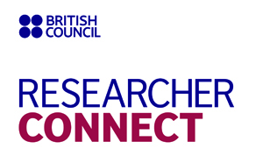

Application form
Full name

Date of birth

Place of work

Job position

Field of research

International research experience

Contact information (mobile number, email address, Skype name if available)

Which workshop (1 or 2) would you like to take part in?

Level of English language competence

Please explain why you wish to take part in the workshop
(up to 100 words)

Date of application

Signature

Please complete the application form and send it to the British Council on the email address: viktor.kyrylenko@britishcouncil.org.ua. Deadline for submitting applications is 20 September 2015.
Contact point for enquiries: Viktor Kyrylenko, Contracts and Projects Manager, Tel.: (044) 490 5600.

